For everyone using the www.arthur-ransome.org website and also who pay manually
The GDPR require you to verify the data we hold on your behalf regularly. If you pay annually online that process is automatic as the new data you type in overwrites previous data. For those that use the manual options (Standing Order, cheque, Direct Bank Transfer (BACS)) or have been kind enough to use Direct Debit which saves us so much work, we will write to you in Signals at the end of every odd year to remind you to check your data online. If you have not given us an email address we will ask you to write to us confirming that your data is up to date. This is a legal requirement.
When we are asked to manually alter data on your behalf it is horribly easy for mistakes to creep in as the data for all members is live in a huge spreadsheet in small type. If you check your own data, only your data is on show and alterable, so very much safer. Obviously people who are not on the internet need us to do this for them.
Please use the email address you registered with us when using the Payment site as it uses this to verify that you are a member. Please ensure that you enter your data accurately. What you put in is what will appear on any envelope we send out, so a literary society sending out an envelope like this is not desirable, and yes we have had ones as bad as this!
siana qroght
9 doveys ter
kungtpn ;ang;ey
Also please note that Royal Mail follows the international postal guidelines where the POSTAL TOWN is CAPITALISED. We do ask for County as the UK regions are worked out by county. For this, London is one.
Please check your publication distribution method. What is on your My Member Info is what we will do. The choice of member type doesn’t offer an option for Outlaw, as we assumed that whatever you chose for Mixed Moss would be the same for Outlaw, but this has proved not to be the case in a small number of cases. Just use the Notes box on the payment page to alert us to what you want, including no Outlaw.
Please bear in mind that the membership did not raise money for the website, all the costs came from volunteers’ time, ingenuity and the savings that the pandemic caused by using Zoom for meetings. A rewrite of the payment site alone would be in the order of £50,000, and so, unless the membership wishes to raise that money, it is not a viable option. Working with the current system, instead of criticising, is a better option.
View My Member Info
When your information loads there is an UPDATE button bottom left, which means that you can change the data and save it. It may take some time to change on the database and then show your new data on your screen. Sometimes it is best to go back next day to check it.
The worst part of the membership team’s job is managing Standing Orders, as so many are incorrect and the owners do not respond to our multiple entreaties to correct them. Any other method of payment is preferable if you are not prepared to keep yours correct.
For the inexperienced internet user. The process of renewing online is simple but for the novice may seem daunting so here are the pages you will encounter:
You enter the members’ area by one of two routes:
www.arthur-ransome.org and choose the lower menu tab Members’ Area which initiates the password logon, or
https://members.arthur-ransome.org/members-area/ which takes you to the same place.
You can tell that you are in the Members’ Area as the top of the Home page has the books in a banner. Your username was sent to you, but send an email to webmaster@arthur-ransome.org and I will remind you. If you cannot remember your password use Forgotten Password to make a new one.
On the top right you see My Account. If you put your mouse (hover) over this it opens to Payments and Renewals and My Member Info. Check what you have registered with us to make sure it is up to date in My Member Info. Check your publication post/electronic choice. Then, if you need to make no changes (Update My Info), go to Payment.
Take care to Renew and do not make yourself a new member! You can make an Additional Voluntary Contribution (Donation) or other purchase on the one transaction.
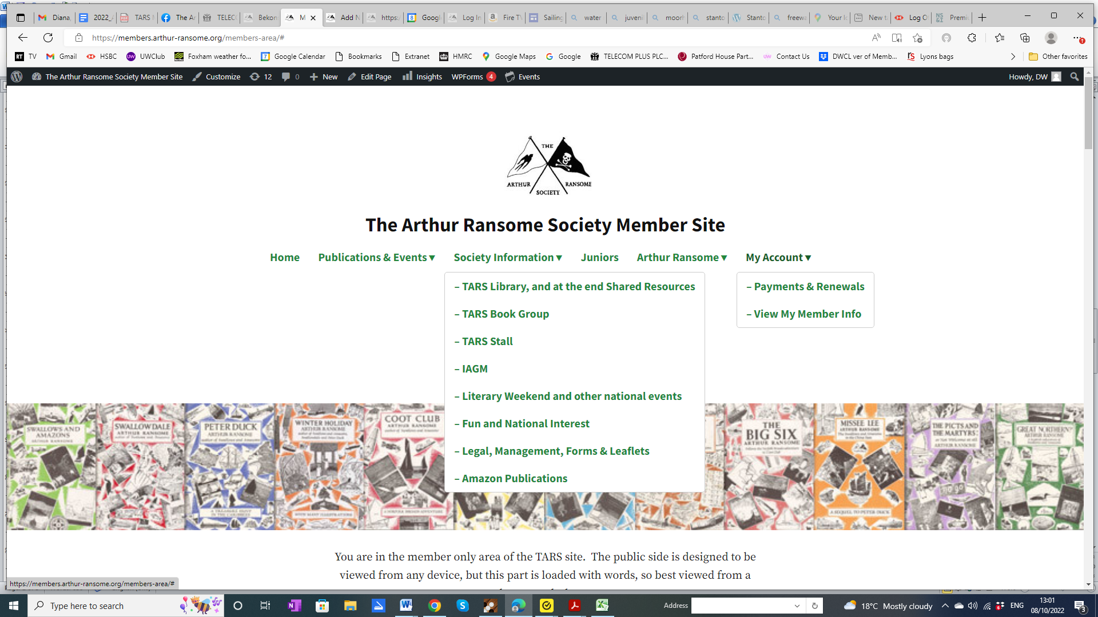
Here!
The Payment first page:
- So you have chosen UK or overseas Renewal. I have chosen UK:  Renewals this side! |  | - Scroll on for the other options.  Notice that it tells you not to proceed if you have already elected to pay by DD, unless you wish to add a donation. The way our debt collecting system works if you overpay it assumes that you meant the money as a donation if you have not specified a donation.
3) |  | - And proceed to checkout.  Here you will be asked for your address, please make sure that it is your POSTAL address, and Royal Mail prefer your TOWN to be in CAPITALS. You can always change the address the following day in My Member Info. What you put in overwrites what we used to hold.  Do fill in the last box WITH YOUR MEMBER NUMBER (it is beside your name on the address labels for your publications) and any other information you think we might need, if you are paying for another member for example.  There has been one problem: a few Overseas members have hit an error, “Billing County Required”. We hope that has been fixed, but if you came across this or any other errors, please email webmaster@arthur-ransome.org as we cannot fix them if we don’t know about them.
6)
Now you can wander round the rest of this large site to see what goodies there are.

In conclusion, we do hope you enjoy the website and choose to see up to date information through it.

Diana Wright 1/5/23

